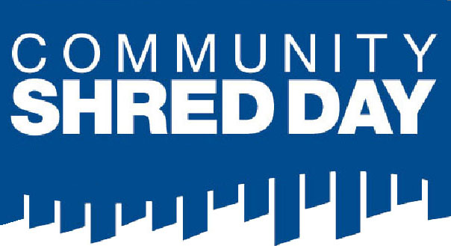
Protect your identity and the environment!
Saturday, July 20, 2019
9am – 1pm
Borough of Haledon
Recycling Center at 510 Belmont Ave.
Shredding Mobile Trucks will provide quick,
confidential destruction of your
documents while you wait.
Allowed: Not Allowed:
Copy Paper, Envelopes, Food wrappers, carbon
Ledgers, Medical Records, paper, plastic materials,
Tax papers, Bank Statements binders, Metal bindings
Must be a Haledon resident. Questions? call (973)595-7766 x 104

